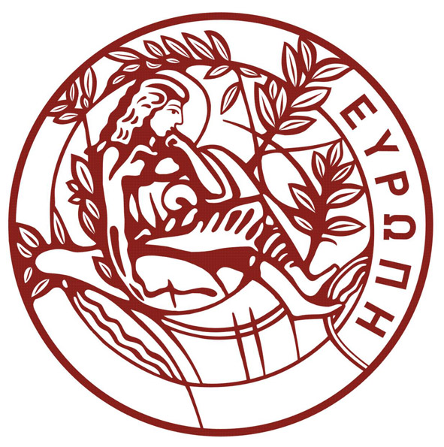
HELLENIC REPUBLIC
UNIVERSITY OF CRETE
ΕΛΛΗΝΙΚΗ ΔΗΜΟΚΡΑΤΙΑ
ΠΑΝΕΠΙΣΤΗΜΙΟ ΚΡΗΤΗΣ
DEPARTMENT OF BIOLOGY
Voutes University Campus, 700 13 Heraklion, Crete, Greece,
Tel.: +30 2810 394400-3
E-mail: secbio@uoc.gr
ΤΜΗΜΑ ΒΙΟΛΟΓΙΑΣ
Πανεπιστημιούπολη Βουτών, 700 13 Ηράκλειο Κρήτης,
Τηλ.: 2810 394400-3
E-mail: secbio@uoc.gr

Call for PhD applications

The Department of Biology, University of Crete (U.o.C.), is warmly inviting prospective candidates to apply for PhD studies throughout the year.
Applicants must be holders of a Master’s degree awarded by a Greek University or a Foreign University recognized by DOATAP . The candidates’ background knowledge must be relevant and of equivalent quality standards as those of our Department. Candidates who do not hold a Master's Degree may be accepted, as long as they comply with the Department’s prerequisites.

Candidates should submit the application using the https://postgrad.cict.uoc.gr website only. If you are using it for the first time, you will be required to register submitting your personal data.
The application and supporting documents are submitted electronically via the website https://postgrad.cict.uoc.gr where applicants must create a user account in order to process their application.
You are invited to complete/submit online at https://postgrad.cict.uoc.gr

1.An application form
2.A motivation letter
3.Two letters of recommendation (indicate the names and e-mails of the persons from whom the letters of recommendation have been requested). The letters of recommendation will be sent directly by the authors).
4.One photo ID.
Αnd attach
5. Thesis acceptance letter from the supervisor of the doctoral thesis
6. Application for the establishment of a three-member advisory committee (the corresponding form is available on the platform - Supplementary files)
7. Summary of the proposed topic for the PhD thesis
8. Full curriculum vitae, including information on the candidate's studies, research or professional activity, possible scientific work and interests.
9. Copy of a BSc degree
10. Copy of MSc diploma.
11. Certificate of analytical marks of the BSc degree and the MSc Diploma
12. Documentation of sufficient knowledge of English (level B2)
- For holders of equivalent degrees from foreign universities, the copies of the BSc degree and MSc Diploma and the transcripts of records must be either in English (from English-speaking Departments) or in Greek language (with official translation from the Greek Embassy or from a certified lawyer).

For scanned certificates and files
You can only attach pdf files.
Maximum allowed size of each file = 2MB.
Total maximum allowed file size = 20MB.

For Photo
You can attach files of type: .png, .jpeg
Maximum Size: 2MB
Dimensions: 200px x 200px

For additional information you can contact the secretariat of Biology Department (bio-grads@uoc.gr) , tel. 2810394402.)

